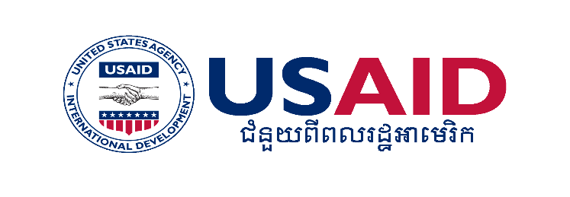

***Key information***

***on***

***Current procedure and costs to migrate to Thailand – version 15/09/2014***

**For legally working in Thailand, you can go to a One Stop Service (OSS) to get the documents you need.**

There are 4 OSS in Cambodia:

* Poipet, Banteay Meanchey;
* Prum, Pailin;
* Osmuch, Oddar Meanchey;
* Cham Yeam, Koh Kong.

You need to:

* Present the non-Thai resident card, or/and a job contract, or/and CI or/and any other documentation that shows that you are employed in Thailand.

**Pay** for registration package: passport $4, visa $20, work permit $10, oversee Cambodian worker card $10 and **wait for 20 working days**

* **You will receive 3 documents:**
  + Oversee Cambodian migrant worker card
  + Passport + working visa
  + Work permit

**With these documents you can migrate and legally work in Thailand.**

***You will have access to Social Security Fund (please check that your employer complies with the law and provides the contributions for you) and you may change employment with justification.***

***\*You can also ask a private recruitment agency to prepare all documents for you. The company will charge a fee. Please check that it is a licensed and reliable agency.***

**In Thailand, undocumented migrants can also register at One Stop Services.**

There are 83 OSS in 77 provinces of Thailand. The registration period is until October 31, 2014 and the documents provided are valid up to March 31, 2015.

You need to show:

* Employment contract, or/and Work permit, or/and Non Thai resident card.
* Have your **blood and urine tests taken**. The tests performed are: presence in urine of methamphetamine, pregnancy test and VDRL test (syphilis).
* **Pay** for registration package: **1,305 TBH** (1,080 THB for any dependent residing in Thailand)

You will **receive:**

* Temporary Work Permit (60 days). Automatically extended to March 31, 2015 (no need to pay extra money or to go back to OSS)
* Health insurance for 3 months (Need to pay for extension)
* ID Card

**With these documents you can work legally in Thailand only up to March 31, 2015. If you come back to Cambodia, you can go to an OSS in Cambodia and get a passport by presenting your temporary registration in Thailand.**

Regulations may change in the coming months. CTIP II Program will keep informing migrants about any changes.